Brian Blackman

7-1 Final Project Submission

Southern New Hampshire University

03/02/2025

**Reflection:**

In this course’s project I was tasked with the role of C++ and OpenGL 3D graphics developer. The company I worked for was Triangle and Cube Studios, they design customized 3D worlds for clients. In this project the client wants to replicate a 3D version of a 2D image. This 3D version will later be used for a 3D printed concept. Therefore, the company only needs a basic visual of the image using simple shapes.

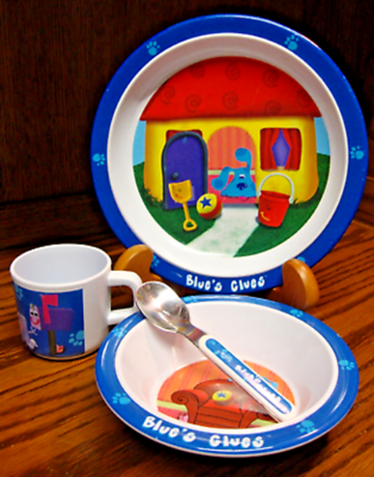

The Image above shows the selected 2D image for this project, which will be used to replicate into 3D form. The image shows a blues clues set of kitchenware. It has a plate sitting upright on a stand with a cup and bowl with a spoon inside of it, these all resting on a wood surface. As the C++ and OpenGL 3D graphics developer, I believe this image will be suitable for this 3D replication. Although, it may not be an exact 3D replication, it will be a simple approximation using a few basic shapes.

In the above picture you see a 3D replication of the 2D image with a slight difference. The plate was made from a flatted cylinder and angled to sit upright. The stand was made out of a complexed shape using boxes that was stretched to a rectangular shape and two half spheres to create the radius shaped ends to hold the plate in place. To the left is the cup made from a basic cylinder shape and the bowl and spoon which sits in the foreground. The bowl was made from a tapered cylinder to keep it simple. The spoon was more made of a complex shape involving a cylinder and two rectangles. The spoon and the stand were made of complex shapes to give an exact look of the 2D image. The plate and cup were made of basic shape to keep it simple to meet the clients’ needs.

To give the client the ability to navigate the 3D image in the 3D version of the 2D image. The left image is of the navigation features, using the QE for up/down movement and WASD for forward/backward and left/right movement. If the code needed to be modified there are comments within the code to help with which piece of code alters the 3D image. There are also lighting and texture customization to get the 3D print to represent the 3D model as close as possible.